**Steps to Configure Codeceptjs**

Create one folder and open in VSCode. Open terminal and follow below steps to configure codeceptjs.

**Step 1:**

npm init -y

**Step 2:**

npm install codeceptjs webdriver --save-dev

**Step 3:**

npx codeceptjs init

**Step 4:**

npm i @wdio/selenium-standalone-service --save-dev

**Step 5:**

npm i @wdio/cli --save-dev

**Step 6:**

open codecept.conf.js file and replace Highlighted lines.

 WebDriver: {

      url: 'http://localhost',

      browser: 'chrome',

      host: '127.0.0.1',

      port: 4444,

      restart: false,

      windowSize: '1920x1680',

      desiredCapabilities: {

        chromeOptions: {

          args: [ /*"--headless",*/ "--disable-gpu", "--no-sandbox" ]

        }

      }

    }

  },

plugins: {

    screenshotOnFail: {

      enabled: true

    },

    retryFailedStep: {

      enabled: true

    },

    wdio: {

      enabled: true,

      services: ['selenium-standalone']

    }

  },

**Step 7:**

Open package.json file and replace below dependencies and run below command:

npm i

 "devDependencies": {

    "@wdio/cli": "^5.18.6",

    "@wdio/selenium-standalone-service": "^5.16.10",

    "codeceptjs": "^2.4.3",

    "webdriver": "^5.18.6"

  },

  "dependencies": {

    "node-fetch": "^2.6.0",

    "sample-testnpm-package": "^1.0.2",

    "wdio": "^4.0.0"

  }

**Step 8:**

Open login_test.js and add steps

Feature('login');

Scenario('test something', (I) => {

I.amOnPage("https://www.hrmantra.com/login.aspx");

I.wait(5);

I.see("abcsh")

});

**Step 9:**

Command For execution:

npx codeceptjs run

**Step 10:**

For gherkin initialization:

npx codeceptjs gherkin:init

after this new folders (features & step_definitions) will be created with sample .feature and .js file

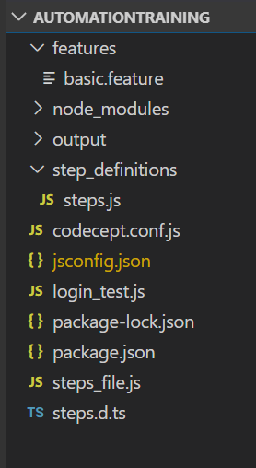

And you can see one property also added in codecept.conf.js file with feature file and steps definition file path

gherkin: {

    features: './features/*.feature',

    steps: ['./step_definitions/steps.js']

  },

Now you can write your cases in gherkin (BDD) format.